Task 5 ELEVATE LABS: Harshitha M

Capturing network traffic using wireshark

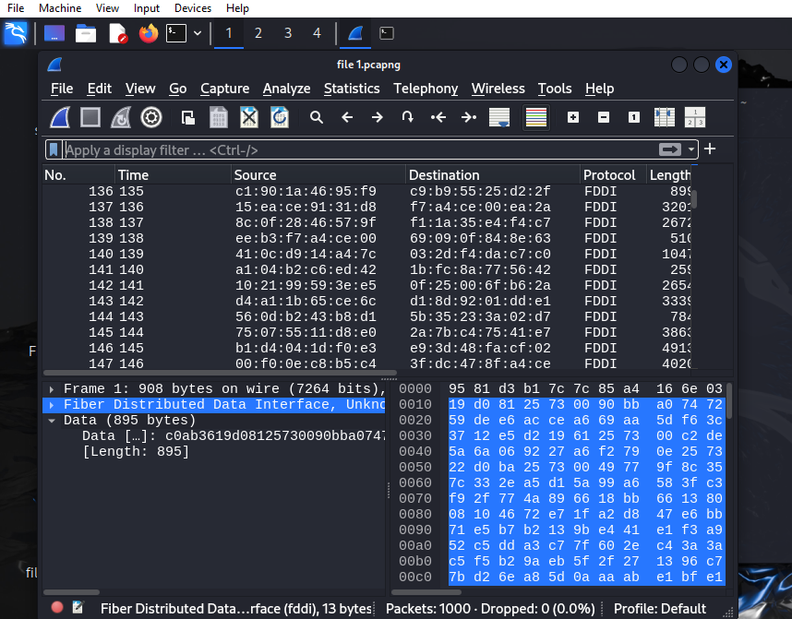

**General Observations**

* **Protocol**: All the packets captured are using **FDDI (Fiber Distributed Data Interface)**.
* **Length**: Varies from ~255 bytes to over 4000 bytes.
* **Data View**:
  + In the lower pane, you're viewing the **raw hexadecimal data** of a selected packet.
  + This includes both **hexadecimal values** and their **ASCII** representation.

**Detailed Breakdown of One Frame**

Example: **Frame 1**

* **Length**: 908 bytes on wire
* **Protocol**: FDDI
* **Raw Data** (first few bytes):

**Interpretation**:

* + The FDDI protocol is **not commonly used** in standard home/office environments. This could be synthetic test data or from a virtual interface.
  + FDDI is a legacy high-speed LAN protocol using **fiber-optic** or **shielded copper**.
  + The raw data doesn't clearly indicate high-level protocols like HTTP, DNS, or TCP, so it's likely **non-IP or encapsulated data**.